**25.1.1**

It's good to see you Shen

Nice to see you

How's thing? I heard you were not good with a door man, but great at the school. Does you have your check?

Yes, I did, thank you. The job was interesting but they wasn't the job I want it

What do you mean?

Well, you are Madi Blum, famous agent to Hollywood actor. I want to be an actor but all of the job you said me on was regular jobs

Wait, did you think I was Madi Blum with Hollywood agency

You are not?

No, this is in this first time for them mistake. That Madi Blum lives in Hollywood. This Madi Blum lives in NY. I spell my name, with a "I", Mady spell it with a "Y"

Oh, so you can get me an acting job?

I didn't say that, I know a lost of people in NY and some of them are in movie business. I think I can get you an acting job. You need to give me a little time, and I need to know more about you. Once I know better, I can find the perfect acting job for you

That's great, thank Madi. What do you want to know?

Tell me about yourself? I know you live in apartment. **Do you share your apartment with a roommate or do you live by yourself?**

**No, I don't live by myself**, **I live with a roommate. His name is Benny**

That is start, tell me more about yourself?

I'm from China, my mother and father still live there. My grandmother lives with them in the house. I don't have any brother or sister. I was an medical school. Because my parents want me to be a doctor

A doctor, huh?

Yes, but I left medical school a and move to NY to be an actor. I met Dan Blaz in China when I was a kid. I want to be an actor like him

Oh, this is good, Shen. **People in Hollywood love stories like yours**

I'm in an acting class now

That's great. What are your hobby? What do you like to do?

I like to act

That's it?

My acting teacher said: that I can only like acting, I have to hate everything that isn't acting

Come on, you have to like something else. **Do you like to play sport? Talk with friend?** watch TV

**I don't play sport**. **I watch TV because Benny watches a lot of football**. I talk to Benny a lot and he is my friend so yet. I live talking with friend

I feel I know you now

Shen didn’t want the jobs he got from Marti.

Shen thought that Marti was a famous Hollywood agent.

Marti thinks she can help Shen get an acting job.

Shen’s acting teacher wants him to focus only on acting.

**Practice**

Can you pass me the salt?

Glen listens to a lot of music

I like a few songs by the Beatles.

I drink water when I’m very thirsty.

This isn’t the first time I heard that story.

Do you have time for a meeting at 3:00?

**Skill Practice**

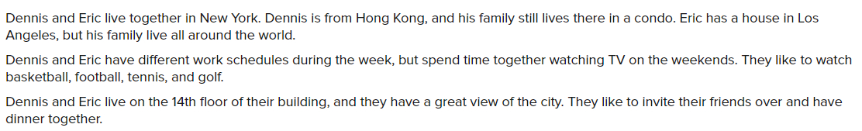

Dennis and Eric are roommates.

Dennis’ family lives in Hong Kong in a condo.

Eric’s family doesn’t live in the same place

Dennis and Eric watch a lot of sports on TV.

Dennis and Eric live in an apartment.

Dennis and Eric like to invite friends for dinner.

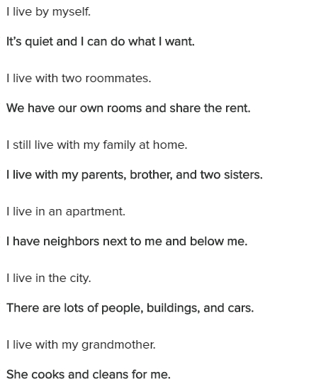

**Conversation**

It’s good to see you Paul. Are you still live in with your parents?

No. I moved to Los Angeles. I live in in an apartment.

Do you live by yourself?

No, I don’t. I live with a roommate.

Tell me about your apartment

The apartment is small. We have a TV and lots of video games.

Tell me about your roommate

His name is is Hector. He likes to play tennis.

That's nice. Does he have any other hobbies?

Yes, he likes to paint

**Exercise**

I love to listen to music.

My roommate is not kind. He doesn’t like to share, but he eats all my food.

Michael: What are you going to do this weekend?

-> Kendra: I need to go to the bookstore. There are a few books I want to read.

Joel has five sisters, but he doesn’t have any brothers.

I do not have a roommate. I live by myself.

Caroline does not live in an apartment or a condo. She lives in a house.

I have two brothers. They live with my parents in their house.

I have lessons every Monday with my piano teacher.

Oscar: Do you want to read the science books?

-> Peter: Yes, I want to read the books.

My boss is friendly. He likes helping people and talking with people.

Ryan: Tell me about your roommates.

-> Megan: They love playing basketball

**25.1.2**

It’s my mom, can I answer this call?

Of course

Hello mom

Hello Shen, where are you?

I’m at my agent office

Your agent?

Yes, I have a agent now. Do you want to met her?

Yes

Mom, this is Madi, my agent. Madi, this is my mother

Hello Shen’s mother

Hello Madi. Did you get my son an acting job?

Mom

I going to get Shen an acting job very soon

Good. He need money

Ok mom, I have to go now. Good bye. Sorry about that

It’s okay. So, what kind of acting job do you want?

Any acting job

What role can you play?

I can play any role

Well, that’s good. The movie business is big in America but it also big in China and India. May be I can find you acting job there, but you had to have a right look

I can play any role

Hmm. **You’re not tall or large enough to play a giant**

**You’re not short enough to play a jockey.**

**You’re too young to play a millionaire**

**You’re a jactip. But not looking enough to play a model**

Benny was love this

But you make me laugh…Well Shen, I think you have talent, get me some times and I think I get you an acting job

Thank you so much, Madi. When you find the job for me, you call with me by phone or by email or regular mail. I’m in town. And I at home every day

Great, you can read me by email or by phone at work. Every weekday, from eleven in the morning to three in the afternoon

Those is a good hours

When you’re the boss, you get to choose your hour

Can I come back next week to talk again?

Sure

Great, see you next Tuesday, Madi

What does Shen’s mother want?

-> She wants Shen to get a job and make money

What kind of job does Shen want?

-> An acting job

Shen is happy to do all types of acting jobs.

Marti doesn’t think Shen can play any role.

Shen and Marti are going to meet next week at Marti’s office.

Simon is too young to be a grandfather.

Noe is too short to play a basketball

Sara is too small to cook

Mark is too tall to be a jockey

Mary is too young to be professor

Wia is not large enough to play a giant